Narrogin Senior High School

2A MODERN HISTORY

SEMESTER ONE

HISTORY DOCUMENT BOOKLET

THE USA BETWEEN THE WARS

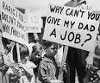

- Four sources

